**QUANTUM ATTRACTION CODE LAUNCH CONTEST**

**MAY 24TH – JUNE 6TH**

**SWIPE #1:**

**SL: Was Einstein a wizard?**

**ALT SL: Einstein makes you a billionaire**

Interested in learning about Albert Einstein’s wealth attraction theory that’s just now surfacing?

Thousands of men and women have quit their jobs to live their best lives after watching this short video.

But you better hurry if you want to be the next success story.

Some very powerful men are trying to have this wiped from the internet completely.

So this is likely your only chance to learn the shocking truth.

[SIGN OFF]

**SWIPE #2:**

**SL: Einstein believed in manifestation?**

**ALT SL: Einstein’s manifestation theory**

**ALT SL: Einstein and quantum attraction**

**—-------------------------------------------------------------------------------------------------**

Most people don't realize that Albert Einstein actually believed in manifestation.

In fact, he even devised his own theory on how to manifest wealth and general abundance without any effort at all.

Only problem is he was missing one key piece of information for his quantum calculations.

However, a stunning breakthrough from Princeton university in 2022 changed everything.

And it was all one of Einstein's living relatives who took the final “piece of the puzzle”...

And finally achieved what Albert Einstein knew was possible.

That any person alive can manifest unlimited money, wealth, and overall abundance.

And now they’ve devised a way to “jump start” your manifestation abilities starting as soon as today.

Discover Einstein's manifestation secret here.

[SIGN OFF]

**SWIPE #3:**

**SL: How to “see” hidden wealth**

**ALT SL: Einstein, Dinosaurs, Manifestation**

Ever wonder how birds know where to go when they migrate thousands of miles away?

Well the answer to that question can actually make you very, very rich.

Reason is, you can use the same quantum science to “see '' hidden wealth all around you.

In fact, Albert Einstein had his very own quantum theory about this.

Of course, this was never released to the public.

But it was passed down the generations inside of Einstein’s family.

And yet no one was able to find the one final missing piece of the quantum equation…

Until now.

Crazy part is, the breakthrough came from Albert Einstein's old employer…Princeton University.

A breakthrough so groundbreaking, it contributed to winning the Nobel prize for physics in 2022.

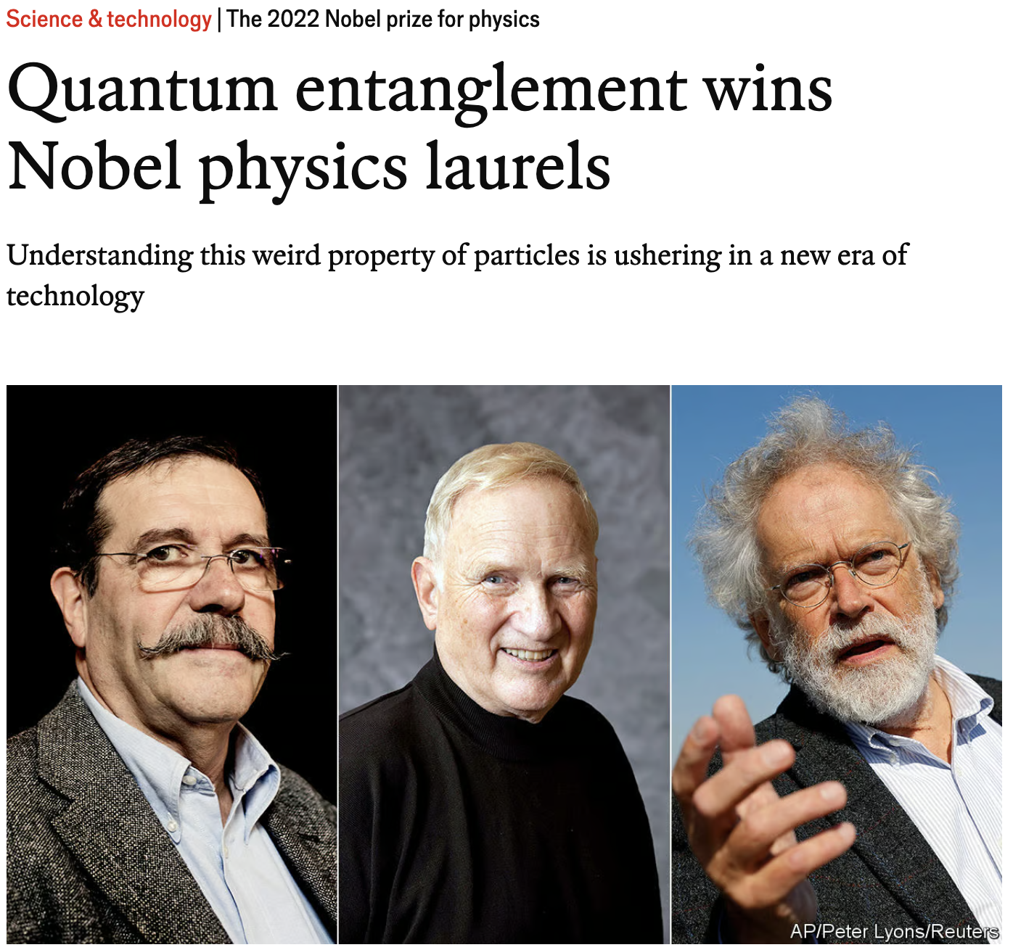

Now that the final piece of the puzzle has been found…

You can “jump start” your manifestation abilities starting as soon as today.

I made a short video about it after a chance encounter with one of Einstein’s living descendants.

But today may well be the last day this secret website is still up.

(You’ll understand why after watching it.)

So I urge you to check it out now.

[SIGN OFF]

**—-------------------------------------------------------------------------------------------------**

**SWIPE #4:**

**SL: Quantum attraction manuscript?**

**ALT SL: Qunatem manuscript for wealth?**

**ALT SL: Was Einstein a fraud? [manifestation]**

What can a centuries old manuscript from India teach us about the science of manifestation?

Well…a lot it turns out.

In fact this ancient manuscript contained quantum science equations that were more advanced than Albert Einstein’s theories in the 1900’s.

And while that might sound a little “out there”, the details get even crazier.

While you’ll never read this in a history book…

The truth is, Albert Einstein actually stole” his famous scientific theory from this ancient manuscript and claimed them as his own.

Now I’m not here to disparage Einstein.

In fact he’s the one who revived the efforts to learn about manifestation.

And his efforts have finally paid off.

Because his living descendants recently had the breakthrough the world has been waiting for.

(*Even though none of us knew it*.)

Discover the breaking news for yourself so you can manifest money, wealth, and overall abundance…

Starting as soon as today.

Which is the first step to changing the trajectory of your life forever.

I urge you to watch this short video now before “big brother” has been removed from the internet permanently.

[SIGN OFF]

**SWIPE #5:**

**SL: Wealth attraction secret that even stumped Einstein**

**ALT SL: The ancient science to attracting abundance**

**ALT SL: Breaking: Albert Einstein's descendants discover wealth attraction secret**

**ALT SL: Einstein's undiscovered secret to attracting abundance**

**ALT SL: Harness the power of quantum attraction**

Albert Einstein was a genius, right?

But even geniuses have puzzles they can't solve, and this one had Einstein baffled.

It's a secret so powerful that it can unlock limitless wealth and abundance from the universe.

It's not a business venture, and it has nothing to do with the "Law of Attraction" you've tried and failed with before.

It's something entirely different. Something groundbreaking...

You see, a direct descendant of Einstein, stumbled upon this secret completely by accident.

Surprisingly, It's not a high-tech solution either.

Instead, it's a simple, ingenious solution ***driven by the law of physics***.

But this method is *also* rooted deep in ancient India.

Albert Einstein worked on this theory for years…

But it was his descendant who put two and two together and made a revolutionary discovery.

And this short video reveals the stunning breakthrough in plain, simple English.

Are you ready to jump-start your way to wealth and financial security?

Discover the Einstein secret and start attracting wealth now.

[SIGN OFF]

**—-------------------------------------------------------------------------------------------------**

**SWIPE #6:**

**SL: Einstein's hidden secret: attracting wealth?**

**ALT SL: Quantum Attraction: The untold story of wealth creation**

**ALT SL: Missing piece to Law of Attraction found**

**ALT SL: The sound of wealth: Einstein's unexpected legacy"**

Did you know that Albert Einstein - yes, THE Albert Einstein - left behind a secret that will change your relationship with wealth and money?

It's not E=mc^2, in fact it’s not ***purely*** a scientific breakthrough.

Instead, it's something much more... spiritual.

Imagine a quantum secret that can "jump start" your quantum attraction abilities...

A concept so powerful, Einstein didn't share it with the world.

(*Just think about that for a moment!*)

But one of his unknown descendants (*We’ll call her “Brenda”*), turned this secret into reality.

And she took this ancient knowledge and merged it with modern technology to create a solution that will impact your financial life forever.

This isn't about working harder.

It's about aligning yourself with the financial abundance you deserve.

This stunning solution is inspired by the ancient Indian scriptures of Vedas…

AND the earth's magnetic field that guides birds on their migratory paths.

So this is not the typical witchcraft or pseudoscience you usually see on the internet.

It's about the secret ingredient that's proven by the law of psychics.

Which is the missing piece of the puzzle for you to attract wealth.

This video will change the trajectory of your life.

Just make sure you watch it now.

It may be removed from the internet as soon as tomorrow (*More on that in the secret video*).

[SIGN OFF]

**—-------------------------------------------------------------------------------------------------**

**SWIPE #7:**

**SL: Einstein's secret theory: Unleashing the power of wealth attraction**

**ALT SL: What the law of attraction missed: Einstein's secret theory for wealth**

**ALT SL: Revealed: quantum attraction secret for wealth**

**ALT SL: The science of wealth: Einstein's untold theory**

**ALT SL: Ancient wealth attraction secrets meet modern science**

Does the thought of attracting wealth and abundance seem like a far-off dream?

Maybe you’ve tried the "Law of Attraction", starting a side hustle, or even diving into astrology…

And yet you always find yourself still struggling?

You're not alone, and it's not your fault.

Millions of others just like you have faced this same struggle.

The truth is that there's a hidden cause that's been preventing you from manifesting the abundance you deserve.

This stumbling block remained unknown until recently when the secret was discovered hiding in plain sight.

A wealth secret inspired by Albert Einstein that "jump-starts" your "quantum attraction" abilities.

Yes, you read that right.

This revolutionary breakthrough was inspired by the great Albert Einstein himself and brought to fruition by one of his unknown descendants.

It taps into the power of vibrational frequencies, giving you a direct, almost magical, channel to the abundance you seek.

The best part?

Harnessing this powerful tool does not require you to start a business, work overtime, or rely on the unpredictable "Law of Attraction".

It delivers the desired outcome without the stress and effort of common practices you've already tried.

This unique solution has already begun transforming lives.

Imagine freeing yourself from financial worries and stepping into a world where abundance is your new normal.

Wouldn't that be incredible?

You can harness Einstein's secret for abundant wealth.

[SIGN OFF]

**—-------------------------------------------------------------------------------------------------**

**SWIPE #8:**

**SL: Manifest Abundance Effortlessly: The Einstein-Inspired Solution"**

**ALT SL: Attract wealth like a bird to a magnetic field**

**ALT SL: Attract limitless prosperity with the secret Einstein method**

**ALT SL: Ditch the overtime: Discover Einstein's secret to quantum wealth**

Have you ever wondered why some people seem to attract wealth effortlessly while others toil day and night, only to stay in the same spot?

They say it's all about working harder or smarter, but what if I told you there's a hidden element involved?

A secret that could "jump-start" your "quantum attraction" abilities?

And maybe right now you're wondering, what's quantum attraction?

Isn't that similar to the Law of Attraction that has failed so many of us?

But the truth is unlike anything you’ve ever seen or heard before.

Thanks to the genius mind of Albert Einstein (*yes the same man who discovered the theory of relativity*).

You see when he died, he was working on a new theory…

A secret so profound that he couldn't fully explore in his lifetime.

Fast forward to today, and one of Einstein's obscure descendants has unearthed this secret, fine-tuned it, and made it available for you and me.

Inspired by the way birds navigate using the earth's magnetic field, she discovered a secret that can "jump-start" our innate ability to attract wealth and abundance.

Just like birds that “magically” seem to find their way home…

You too can navigate your way towards a life of financial security and abundant living.

Now, I know this sounds like a lot to take in, and you're probably skeptical.

But when you see the truth, it’ll feel like your eyes have just opened for the first time.

Because this is about tapping into a powerful force that has been dormant within you, waiting to be awakened.

And the best part is you can start as soon as today.

Which means the ability to attract unlimited wealth and abundance is right at your fingertips.

Imagine the freedom from your job, financial security for your family, and the luxury that comes with it.

You’ll see how to make it your reality in this short video.

[SIGN OFF]

**—-------------------------------------------------------------------------------------------------**

**SWIPE #9:**

**SL: Einstein’s wealth attraction beliefs**

**ALT SL: Einstein, spirituality, and wealth**

A stunning new report is now showing that Albert Einstein believed in wealth attraction.

The crazy part is his theory was as mch based in ancient eastern speciality as it was the law of physics.

And now a stunning documentary-style video has been leaked from one of Einstein’s descendants.

Connecting all the dots so that YOU can attract wealth and abundance on command.

Supposedly this is the only day this short video will be in the public domain.

Which means this is the one and only chance you have to change the trajectory of your life forever.

Don’t let it pass you by.

[SIGN OFF]

**—-------------------------------------------------------------------------------------------------**

**SWIPE #10:**

**SL: Einstein manifestation secret?**

**ALT SL: Einstein wealth secret?**

Stunning news from one of Albert Einstein's descendants revealsa manifestation secret.

A manifestation secret that’s been hidden away for decades…

Until now.

Because a shocking breakthrough from Princeton University has changed everything.

And for the first time in history, anyone and everyone can “jump start” their internal manifestation abilities

Which means YOU can use Einstein’s manifestation method to attract unlimited wealth and abundance.

And that groundbreaking study from Princeton university makes this method virtually effortless.

I urge you to get started today, because I don't know how much longer this secret website will be up.

See ya on the inside.

[SIGN OFF]

**—-------------------------------------------------------------------------------------------------**

**—-------------------------------------------------------------------------------------------------**